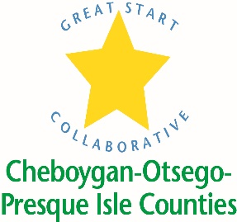

May 26, 2020

Due to COVID 19 and the uncertainty of what preschool will look like in the fall, we are NOT awarding preschool scholarships until late August or beginning of September 2020. We ARE accepting the scholarship applications, and we will be holding onto them until August meeting. Parents are still encouraged to apply so that we have the applications on hand.
We have very limited funding this year, especially in Cheboygan and Otsego Counties. If we do not receive additional funding for these two counties, scholarship awards will be extremely low.
Parents need to send in a COMPLETED application, along with current proof of income. If we do not have the proof of income and the application is not complete with signature(s), the applications will be an automatic denial. This is due to the time constraints, number of applications and the uncertainty of what the fall will hold.

Melinda Hambleton
Great Start Coordinator Cheboygan, Otsego, Presque Isle
mhambleton@copesd.org/989-306-0683

